Drama Facilitator
January 2019

- Welcome and How to Apply
- Job Description & Person Specification
- Application Form
- Equal Opportunities Monitoring Form
- Theatre Royal in Brief
- How to find Theatre Royal

[Please save paper – do enjoy reading the following pages, but please only print what you really need. Thank you]

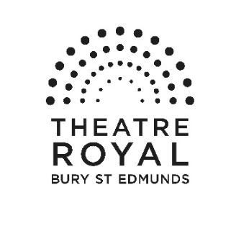

Vacancies at Theatre Royal Bury St Edmunds

Thank you for your interest in joining the team at Theatre Royal. Please find enclosed a job description for the post of Drama Facilitator and some information about Theatre Royal which I hope will encourage you to apply to join us. Further information about the theatre can be found on our website: www.theatreroyal.org.

If you would like to be considered for this post, please complete and return the application form and accompanying paperwork by midday on Friday 1 February; interviews will take place on Tuesday 12 February.

Applications will be accepted by email to jobs@theatreroyal.org or by post.

Please address your application to

Recruitment, Sharron Stowe, Theatre Royal, Westgate Street,
Bury St Edmunds, Suffolk, IP33 1QR

Good luck and thank you for your interest in working at Theatre Royal.

Yours Sincerely

Karen Simpson
Artistic Director

Drama Facilitator

Job Description

Purpose of post

The Education programme at Theatre Royal is committed to providing young people across Suffolk with the opportunity to learn from highly experienced Theatre Practitioners, watch performances from some of the leading children’s theatre companies internationally, get on stage and perform, build confidence in a familiar and friendly environment and Drama Facilitators are an integral part of its delivery.

This post is a flexible zero hours contract. It is anticipated as minimum 2 hours and with the potential to cover a maximum of 12 hours per week as part of the After School Drama Club Programme. There will also be the opportunity to lead on other projects within the Education Programme.

Department: Creative Learning Responsible to: Education Projects Officer

Areas of Responsibility

Practical Workshop Delivery

- To lead on, plan and deliver allocated After School Drama Club sessions in rural/town Primary Schools.
- To create cohesive workshop plans exploring a range of theatrical styles in order to build on the participant’s skillset within sessions.

- To cover workshops other than those allocated to you when other facilitators are unavailable (where possible).

- To deliver from time to time further project based work in consultation with the Education Projects Officer throughout the term, this may include: Teacher Forum Evenings or running bespoke workshops at Theatre Royal and in schools.

Work as part of the Creative Learning Team

- To attend termly meetings with the Education Projects Officer.

- To act as a mentor to the young people on our Young Associates scheme who will assist After School Drama Club sessions.

- To be an ambassador for the Education Programme and Theatre Royal, actively promoting the work and helping to maintain the high professional standard of the profile.

- To be a positive role model for participants, encouraging confidence and providing strong support so they can actively engage in the sessions.

- To work within with our Safe from Harm policy at all times.

To undertake any other reasonable duties as requested by Management.

The duties must at all times be carried out with due regard to all Theatre Royal Policies, which are detailed in the Company Handbook.

Person Specification
Essential
- Degree Level in a Performing Arts subject.
- Experience as a Theatre Facilitator running workshops with young people.
- In depth knowledge and understanding of theatre practice with the ability to apply a range of techniques and approaches in workshop settings.
- Experience of delivering participatory programmes.
- Ability to work efficiently to project briefs, deadlines and budgets.
- Excellent communication and interpersonal skills with the ability to build strong relationships with teachers and participants.
- Experience of directing theatre with groups of young people.
- Ability to work independently and as part of a wider group.
- Willing to work flexible hours including evenings and weekends during busy periods.
- Ability to work with a group of young people with a range of additional needs.
- Full driving licence and transport

Desirable
- Knowledge and experience of working within a school context
- Knowledge of a range of other art forms.
- Paediatric first aid trained.

Terms & Conditions

Contract: This is a zero hours contract and subject to a one month notice period

Salary: £30 per session (£15 per hour for preparation and delivery)

Hours of work: 2 hours per week with the potential for up to 12 hours depending on cover:
Monday 3.30pm – 4.30pm
Tuesday 3.00 – 4pm & 3.20pm – 4.20pm
Wednesday 3.30pm – 4.30pm
Thursday 3.15pm – 4.15pm
Friday 3.30pm – 4.30pm
This post may include some evening and weekend work when necessary.

Place of work: Theatre Royal and local schools.

Annual Leave: You will be paid statutory holiday pay.
Allowances: Travel/mileage expenses whilst on Theatre Royal business.

Staff members receive an allocation of complimentary tickets for some performances at Theatre Royal for personal use only.

Pensions: We offer a workplace pension in line with statutory requirements.

Other information: There is a comprehensive staff handbook and induction plan with detailed information on policies, practices and working arrangements offered to all staff.

This position is subject to the receipt of an Enhanced DBS Certificate.

Please read the documents which accompany this form before completing your application.

Once completed, please return the form to jobs@theatreroyal.org or via post to arrive by

12 noon on Friday 1 February.

Position Applied for | Drama Facilitator

1 Personal Details

Surname
Forename(s)
Address | Postcode
Telephone (day)
Telephone (evening)
Email address
National Insurance Nº

2. Why are you applying for this post?

3. What can you offer us?
Please include details of any relevant skills, experience and knowledge (there are later sections for information about training and education)

4 Current or most recent employment/experience of work

Name and address of organisation | Postcode
Position held
Salary (if applicable)
Date appointed
Date left appointment and why (if applicable)

Outline briefly your duties and responsibilities

5 Previous appointments/experience of work

Name and address of organisation | Position held and dates | Main duties and responsibilities | Reason for leaving
6 Training and education
Please include details of exams passed, courses attended and qualifications obtained

7 What else are you interested in?
for example, what are your leisure activities

8 Additional Information please delete where applicable

Do you need a permit to work in the United Kingdom? YES / NO

Do you have any condition or disability which may affect your ability to do the job, and/or require us to make reasonable adjustments? YES / NO

If Yes please give details including any adjustments that you may need to be made both in respect of the job and the interview

9 Travel
Some positions at the Theatre Royal require employees to drive, if this is applicable to the position you are applying for, please complete this section

Do you hold a current, clean driving licence? YES / NO
Do you have access to/have the use of a car? YES / NO

If the answer to either of these questions is No, please explain how you would meet the travel requirements of the post (where applicable)

10. Confidential Declaration of Criminal Record

Some positions at the Theatre Royal require employees to be responsible for or come into contact with young people aged under 18 and vulnerable adults. If this is applicable to the position you are applying for, you will be required to undertake an Enhanced DBS Check.

Please note that all posts which involve working with young people aged under 18 and vulnerable adults at the Theatre Royal are exempt from the Rehabilitation of Offenders Act 1974, which means that all convictions, cautions, reprimands and final warnings on your criminal record need to be disclosed.

Theatre Royal Bury St Edmunds
Equal Opportunities Monitoring

The Theatre Royal is committed to a policy of equality of opportunity in all aspects of its recruitment and employment procedures. All candidates will receive fair and equal consideration.

In order for us to put this commitment into practice we need to assess how well our recruitment procedures operate in practice and it would be helpful if you would answer the questions below and return this sheet with your application form. There is no obligation for you to complete the form.

The information submitted will be treated in the strictest confidence and will be used only for statistical monitoring. It is not part of the selection process and will be separated from the application prior to short-listing.

Position Applied for | Drama Facilitator
Year of Birth
Gender | Male / Female

Please circle or highlight your ethnic origin

Asian/Asian British |  | Black/Black British
Chinese |  | Middle/Near Eastern
Mixed Ethnic Group |  | White/White European
Other (please describe)

Do you consider yourself to have a disability? YES / NO

How did you become aware of this vacancy?
Please tick as many as are applicable and delete where necessary

Publication | Type of advert
Arts Professional | Online / Printed magazine
The Stage | Online / Printed paper
Theatre Royal Website
Stage Jobs Pro
Arts Jobs
Other Internet Site
Other source (please specify)

Please return your completed forms by 12 noon on Friday 1 February.
Theatre Royal Bury St Edmunds
Built in 1819 by the renowned architect William Wilkins (who also designed the National Gallery in London), Theatre Royal Bury St Edmunds is one of the most significant theatrical buildings in Europe. As this country’s only working example of a playhouse dating from the Regency period, it offers visitors a unique and unforgettable theatrical experience. One of eight Grade 1 listed theatre buildings in the country, it is also the only working theatre in the National Trust’s portfolio of properties. Inspired by its impressive historical pedigree, the Theatre prides itself on the quality and innovation of its artistic work and enjoys a reputation as one of the most forward-thinking arts organisations in the UK.

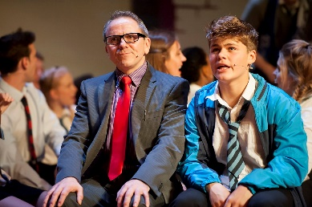
The building itself is owned by the Greene King Brewery. In 1975, it was leased to the National Trust which, in turn, has handed the day-to-day running of the Theatre to Bury St Edmunds Theatre Management Limited. Like many other theatres of its generation, Theatre Royal has enjoyed a chequered history, closing and reopening its doors on a number of occasions. In September 2007, the Theatre reopened following a £5.3 million programme of restoration and development. This project, funded in part by the Heritage Lottery Fund, not only returned the building to its 1819 configuration and decoration but also provided improved customer facilities through the creation of a contemporary foyer space adjoining the Theatre.

With a diverse range of productions the Theatre attracts around 80,000 visitors a year, plus over 2,500 young people and adults engage in creative learning activities in schools or in the community. Over 20,000 people come to see our renowned annual traditional family pantomime plus a wide range of local community and amateur groups regularly present performances on the Theatre’s stage and are essential to the cultural offer to the community.

Theatre Royal celebrates its heritage and, as a National Trust property, welcomes around 2000 visitors a year to enjoy the restored building through guided tours, talks and lectures. The theatre employs a paid staff of 30 and supports a number of internships and apprenticeships, it also has a team of approximately 70 volunteers. It is overseen by a non-executive board of management. There is a Patron's Scheme and a thriving Friends scheme numbering over 600 members. The theatre receives core funding from St Edmundsbury Borough Council and Suffolk County Council and also enjoys strong support from the local business community.

Mission

Theatre Royal Bury St Edmunds presents a high quality programme of performances and creative activities that enrich and inspire children and adults lives.

Aims

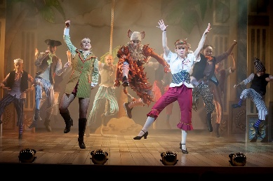
- To present a broad performing arts programme of high quality work from leading arts organisations and emerging artists.
- To work within a range of producing models for Theatre Royal productions.
- To further development of Theatre Royal as a Creative Learning organisation.
- To work within a sustainable business model with a skilled workforce and effective base for its operations
- To develop and grow audiences.
- To build on the trust and support of Theatre Royal’s supporters and stakeholders.
- To celebrate Theatre Royal’s unique heritage.

How to get to Theatre Royal

On arrival, please report to the Box Office at the Theatre.
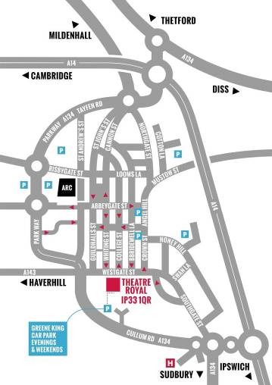
By Road
Bury St Edmunds is just off the A14, east of Cambridge and west of Ipswich. From the Midlands or the East Coast, follow the A14. From London, take the M25 and M11/A11 then A14 heading east (signposted Newmarket / Ipswich / Felixstowe). Approaching from the west, take the third exit for Bury St Edmunds and turn right at the big roundabout towards the town centre. Go right at the next roundabout then right at the third roundabout onto Southgate Street. Follow the road and you will join the one way system; the Theatre is on your left opposite the Greene King Beer Cafe.

Car Parking
The Theatre has no parking of its own. There is very limited parking close to the Theatre. We normally recommend the Angel Hill or Premier Inn car parks as the closest viable options. There are a number of unlimited street parking places on Westgate Street after 6.00 pm.

By Bus
The Bus Station is on St Andrew’s Street North, 10 minutes’ walk from the Theatre. In addition to local services, it is serviced by National Express coach connections from all over the country. Enquiries/Reservations: 01284 702020

By Train
Bury St Edmunds Railway Station is on Station Hill and is 20 minutes’ walk from the Theatre, connecting to Cambridge, Ipswich and the London to Norwich line.
Enquiries/Reservations: 08457 484950

Local Taxis
5 Star Cars 01284 703131 / 01284 704078
A1 Cars 01284 766777
Premier Cars 01284 704004
Star Cars 01284 760707
United Cars 01284 762288 / 01284 764074

