PV10  In-Wall Electric Toothbrush Charger | This product is suitable for use in bathrooms for Oral-B electric toothbrushes only.  Please check with manufacturer’s instructions for suitability with toothbrush model.  This appliance can be used by children aged from 8 years and above and persons with reduced physical, sensory or mental capabilities or lack of experience and knowledge if they have been given supervision or instruction concerning use of the appliance in a safe way and understand the hazards involved.  Children shall not play with the appliance. Cleaning and user maintenance shall not be made by children without supervision.  SAFETY INSTRUCTIONS  All installation work should be undertaken by a competent person in accordance with the current edition of the IEE Wiring Regulations (BS 7671) and appropriate statutory regulations. In the Republic of Ireland the installation must be in accordance with the ETCI National Rules for Electrical Installations -ET101.  IF IN DOUBT, CONSULT A QUALIFIED ELECTRICIAN  Before starting any electrical work, ensure that the electricity supply is SWITCHED OFF at the mains. For additional safety, remove the fuse or switch off the circuit breaker at the fuse box or consumer unit. | IMPORTANT NOTICE – WIRING COLOUR CHANGES  As from 1st April 2004 new installations in the UK could be wired using the new EU Harmonised colours for the supply conductors of twin and earth cable:  New Colours Brown = Live Blue =  Neutral Old Colours Red = Live Black = Neutral  The old colours will cease to be used from 1st April 2006.  Flexible cable colours remain unchanged:  Brown = Live Blue = Neutral  Eire conductor colours for twin and earth cable and flexible cable:  Brown = Live Blue = Neutral | INSTALLATION AND WIRING INSTRUCTIONS  This toothbrush charger unit is suitable for mounting with a 47mm deep 2 gang flush metal box.  Please note – check orientation of box when fitting this unit on a surface pattress box.  For the best mounting results and visual appearance, it is recommended that prior to installation, the mounting surface between the accessory front plate is first prepared to ensure that it is flat and all high spots have been removed.  - Remove product and screws supplied from the packaging  - Feed incoming supply cable through appropriate knockout entry in back box. Ensure a protective cable grommet is fitted when using a flush metal box.  - Remove suitable length of outer sheath from the supply cable. Remove 10mm from the live and neutral inner insulation to expose the conductor ends.  - Insert Neutral conductor into the charger supply unit terminal into either of the 2 available terminals available (mains are bath red so are interchangeable)  - Before connecting the protective earth conductor, ensure that all bare earth conductors are sleeved with a length of Green/ Yellow sleeving (not supplied)  - Insert sleeved earth conductor into terminal marked with the Earth symbol.
- Ensure that an additional sleeved earth conductor is also fitted between the charger unit earth terminal and the earth terminal fitted in the flush metal box.  - Ensure all terminal screws are tight.  - Fit the toothbrush charging unit onto the mounting box, taking care not to trap any cables.  - Secure unit using the fixing screws.  - Ensure that the plastic frame is correctly fitted and then fit the front plate in place.  - Refit the supply fuse (if removed) and switch on mains supply.  - Parts that are required to be fixed should be fixed so that they cannot fall into water.  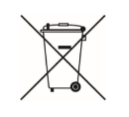  This symbol on the product or on its packaging indicates that this product shall not be treated as household waste. Instead it shall be handed over to the applicable collection point for the recycling of electrical and electronic equipment. By ensuring this product is disposed of correctly, you will help prevent potential negative consequences for the environment and human health, which could otherwise be caused by inappropriate waste handling of this product. The recycling of materials will help to conserve natural resources. | 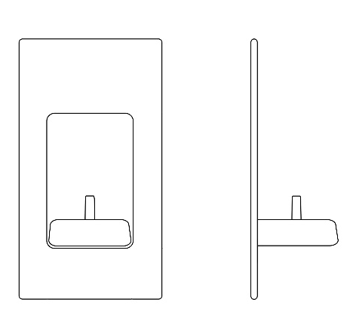  161mm(H) X 89m(W) | 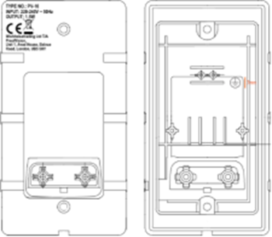 | CUSTOMER CARE CENTRE:  technical@proofvision.co.uk  ProofVision  Unit 1, Avad House,  Belvue Road, Northolt, Middx  UB5 5HY

