Week 6: The Reformation in Europe – map sheet
Map 1: Europe in 1500
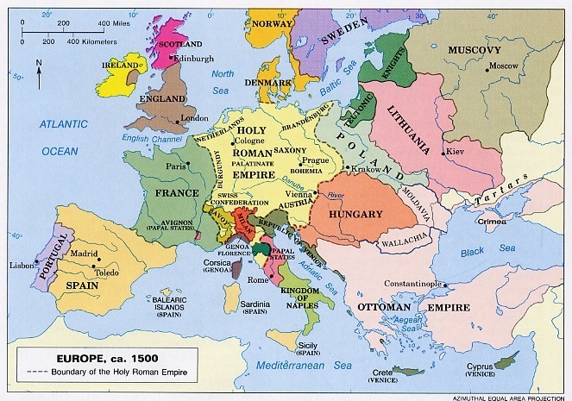
Map 2: The Holy Roman Empire in 1500
