**Week 1: The Church in the first two centuries**

**1.1 Introduction to the Course**

|  |  |
| --- | --- |
| **An Introduction to Church History to 1603** | |
| Date | Topic |
| 21/9 | The church in the first two centuries |
| 28/9 | The church under Rome to 337 |
| 5/10 | Imperial religion and theological conflict |
| 12/10 | The early middle ages in England |
| 19/10 | The Middle Ages |
| 2/11 | The Reformation in Europe |
| 9/11 | The English Reformation to 1558 |
| 16/11 | The Protestant Consensus under Elizabeth 1558-1603 |

**1.2 Why church history?**

**Ephesians 1:9-10**

**1.3. The Church in the New Testament**

**The Church in Acts**

**The Church after Acts**

**1.4. The first non-apostolic generation**

**New situation:**

**Clement of Rome: 1 Clement c95**

**The Didache** - **c101**

**Ignatius of Antioch** martyred **c110/115**

**Shepherd of Hermas c135**

**The Epistle of Barnabas** - **c70/135** –

**Polycarp -** **executed c155**, aged 86

**Continuity and Change:**

**1.5. Relations with Rome until the end of the 2nd century**

**Relations in the book of Acts**

**Nero (54-68)**

**Domitian (81-96)**

**Nerva and (96-98) and Trajan (98-117)**

**Antonius Pius (138-162)**

**The Martyrdom of Polycarp**

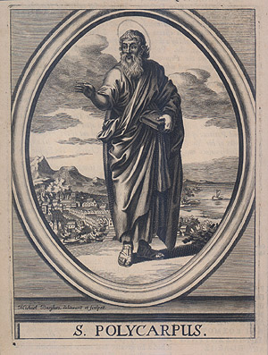

**Chapter 7:** His pursuers then, along with horsemen, and taking the youth with them, went forth at supper-time on the day of the preparation with their usual weapons, as if going out against a robber. And being come about evening [to the place where he was], they found him lying down in the upper room ofa certain little house, from which he might have escaped into another place; but he refused, saying, “The will of Godbe done.” So when he heard that they were come, he went down and spake with them. And as those that were present marvelled at his age and constancy, some of them said. “Was so much effortmade to capture such a venerable man?” Immediately then, in that very hour, he ordered that something to eat and drink should be set before them, as much indeed as they cared for, while he besought them to allow him an hour to pray without disturbance. And on their giving him leave, he stood and prayed, being full of the grace of God, so that he could not ceasefor two full hours, to the astonishment of them that heard him, insomuch that many began to repent that they had come forth against so godly and venerable an old man.

**Chapter 9:** Now, as Polycarp was entering into the stadium, there came to him a voice from heaven, saying, “Be strong, and show thyself a man, O Polycarp!” No one saw who it was that spoke to him; but those of our brethren who were present heard the voice. And as he was brought forward, the tumult became great when they heard that Polycarp was taken. And when he came near, the proconsul asked him whether he was Polycarp. On his confessing that he was, [the proconsul] sought to persuade him to deny [Christ], saying, “Have respect to thy old age,” and other similar things, according to their custom, [such as], “Swear by the fortune of Cæsar; repent, and say, Away with the Atheists.” But Polycarp, gazing with a stern countenance on all the multitude of the wicked heathen then in the stadium, and waving his hand towards them, while with groans he looked up to heaven, said, “Away with the Atheists.” Then, the proconsul urging him, and saying, “Swear, and I will set thee at liberty, reproach Christ;” Polycarp declared, “Eighty and six years have I served Him, and He never did me any injury: how then can I blaspheme my King and my Saviour?”

**Chapter 11:** The proconsul then said to him, “I have wild beasts at hand; to these will I cast thee, except thou repent.” But he answered, “Call them then, for we are not accustomed to repent of what is good in order to adopt that which is evil; and it is well for me to be changed from what is evil to what is righteous.” But again the proconsul said to him, “I will cause thee to be consumed by fire, seeing thou despisest the wild beasts, if thou wilt not repent.” But Polycarp said, “Thou threatenest me with fire which burneth for an hour, and after a little is extinguished, but art ignorant of the fire of the coming judgment and of eternal punishment, reserved for the ungodly. But why tarriest thou? Bring forth what thou wilt.”

**Chapter 14:** They did not nail him then, but simply bound him. And he, placing his hands behind him, and being bound like a distinguished ram [taken] out of a great flock for sacrifice, and prepared to be an acceptable burnt-offering unto God, looked up to heaven, and said, “O Lord God Almighty, the Father of thy beloved and blessed Son Jesus Christ, by whom we have received the knowledge of Thee, the God of angels and powers, and of every creature, and of the whole race of the righteous who live before thee, I give Thee thanks that Thou hast counted me, worthy of this day and this hour, that I should have a part in the number of Thy martyrs, in the cupof thy Christ, to the resurrection of eternal life, both of soul and body, through the incorruption [imparted] by the Holy Ghost. Among whom may I be accepted this day before Thee as a fatand acceptable sacrifice, according as Thou, the ever-truthfulGod, hast foreordained, hast revealed beforehand to me, and now hast fulfilled. Wherefore also I praise Thee for all things, I bless Thee, I glorify Thee, along with the everlasting and heavenly Jesus Christ, Thy beloved Son, with whom, to Thee, and the Holy Ghost, be glory both now and to all coming ages. Amen.”

**Marcus Aurelius (162-180) and Commodus (180-192)**

177 Persecution at Lyons

**1.6. Heretics and Apologists in the 2nd century**

**What is heresy? Galatians 1:6-9**

*What does heresy look like?*

**Irenaeus and Gnosticism**

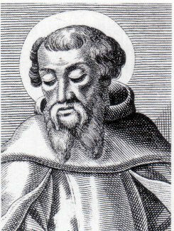

Creation

Salvation

Jesus Christ

### Adversus Haereses - Written between 175 and 189

### Irenaeus on Scripture and Tradition

***Adversus Haereses*** 3.1.1. For we learned the plan of our salvation from no others than from those through whom the gospel came to us. They first preached it abroad, and then later by the will of God handed it down to us in Writings, to be the foundation and pillar of our faith. For it is not right to say that they preached before they had come to perfect knowledge, as some dare to say, boasting that they are the correctors of the apostles. For after our Lord had risen from the dead, and they were clothed with the power from on high when the Holy Spirit came upon them, they were filled with all things and had perfect knowledge. They went out to the ends of the earth, preaching the good things that come to us from God, and proclaiming peace from heaven to men, all and each of them equally being in possession of the gospel of God. So Matthew among the Hebrews issued a Writing of the gospel in their own tongue, while Peter and Paul were preaching the gospel at Rome and founding the Church. After their decease Mark, the disciple and interpreter of Peter, also handed down to us in writing what Peter had preached. Then Luke, the follower of Paul, recorded in a book the gospel as it was preached by him. Finally John, the disciple of the Lord, who had also lain on his breast, himself published the Gospel, while he was residing at Ephesus in Asia. All of these handed down to us that there is one God, maker of heaven and earth, proclaimed by the Law and the Prophets, and one Christ the Son of God. If anyone does not agree with them he despises the companions of the Lord, he despises Christ the Lord himself, he even despises the Father, and he is self- condemned, resisting and refusing his own salvation, as all the heretics do.

### Irenaeus on Redemption

***Adversus Haereses*** 3.18.1. As it has been clearly demonstrated that the Word, who existed in the beginning with God, by whom all things were made, who was also always present with mankind, was in these last days, according to the time appointed by the Father, united to His own workmanship, inasmuch as He became a man liable to suffering, [it follows] that every objection is set aside of those who say, "If our Lord was born at that time, Christ had therefore no previous existence." For I have shown that the Son of God did not then begin to exist, being with the Father from the beginning; but when He became incarnate, and was made man, He commenced afresh the long line of human beings, and furnished us, in a brief, comprehensive manner, with salvation; so that what we had lost in Adam-namely, to be according to the image and likeness of God-that we might recover in Christ Jesus.

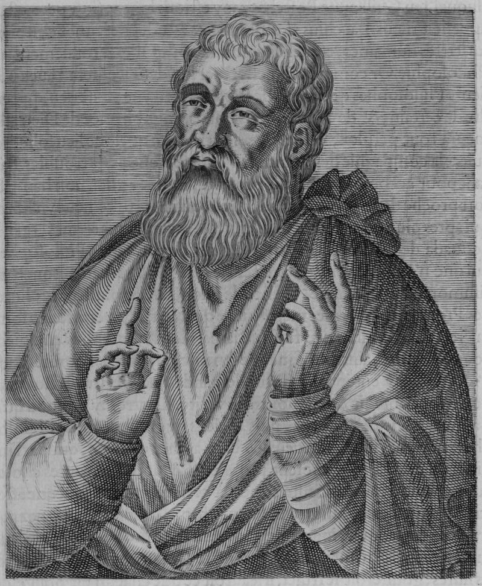

**An Apologist– Justin Martyr d.162**

1st apology 155

2nd apology 160

Martyred 162.

**Justin Martyr’s First Apology**

**Chapter 5**: Why, then, should this be? In our case, who pledge ourselves to do no wickedness, nor to hold these atheistic opinions, you do not examine the charges made against us; but, yielding to unreasoning passion, and to the instigation of evil demons, you punish us without consideration or judgment. For the truth shall be spoken; since of old these evil demons, effecting apparitions of themselves, both defiled women and corrupted boys, and showed such fearful sights to men, that those who did not use their reason in judging of the actions that were done, were struck with terror; and being carried away by fear, and not knowing that these were demons, they called them gods, and gave to each the name which each of the demons chose for himself. And when Socrates endeavoured, by true reason and examination, to bring these things to light, and deliver men from the demons, then the demons themselves, by means of men who rejoiced in iniquity, compassed his death, as an atheist and a profane person, on the charge that "he was introducing new divinities;" and in our case they display a similar activity. For not only among the Greeks did reason (Logos) prevail to condemn these things through Socrates, but also among the Barbarians were they condemned by Reason (or the Word, the Logos) Himself, who took shape, and became man, and was called Jesus Christ; and in obedience to Him, we not only deny that they who did such things as these are gods, but assert that they are wicked and impious demons, whose actions will not bear comparison with those even of men desirous of virtue.

**Chapter 6**: Hence are we called atheists. And we confess that we are atheists, so far as gods of this sort are concerned, but not with respect to the most true God, the Father of righteousness and temperance and the other virtues, who is free from all impurity. But both Him, and the Son (who came forth from Him and taught us these things, and the host of the other good angels who follow and are made like to Him), and the prophetic Spirit, we worship and adore, knowing them in reason and truth, and declaring without grudging to every one who wishes to learn, as we have been taught.

**Montanus – c160+**

## Further Reading

J. Stevenson (ed.), *A New Eusebius*: *Documents illustrating the history of the Church to AD337*. 2nd Edn. London: SPCK, 1987. There are several bits of Irenaeus in this, as well as some Gnostic texts such as an extract from the Gospel of Thomas.

All the documents quoted here and many others can be found online at <http://www.earlychristianwritings.com/churchfathers.html> you can also try <https://www.ccel.org/> for writings of this period.

**1.7 Important Dates and Events**

|  |  |
| --- | --- |
| **Emperors**  14-37 Tiberius  37-41 Caligula  41-54 Claudius | **Events**  30 crucifixion and resurrection of Christ |
| 54-68 Nero | c62 death of James, the Lord’s brother  66 Jewish Revolt  c66 deaths of Peter and Paul |
| 69-79 Vespasian | 70 destruction of Jerusalem |
| 81-96 Domitian | c90/95 death of Apostle John  c96 completion of NT canon  c95/96 1 Clement |
| 96-98 Nerva |  |
| 98-117 Trajan | Didache  c110 Ignatius to Rome  c112 Pliny In Bithynia |
| 117-138 Hadrian | c135 Epistle of Barnabas |
| 138-162 Antonius Pius | c156 Martrydom of Polycarp  c160 beginning of Montanism |
| 162-180 Marcus Aurelius | c165 death of Justin Martyr  177 Persecution at Lyons |
| 180-192 Commodus |  |