**Week 4: The early middle ages in England – c400-1215 – *map sheet***

**Map 2: Anglo-Saxon England c800**

**Map 1: Peoples in Britain c600**

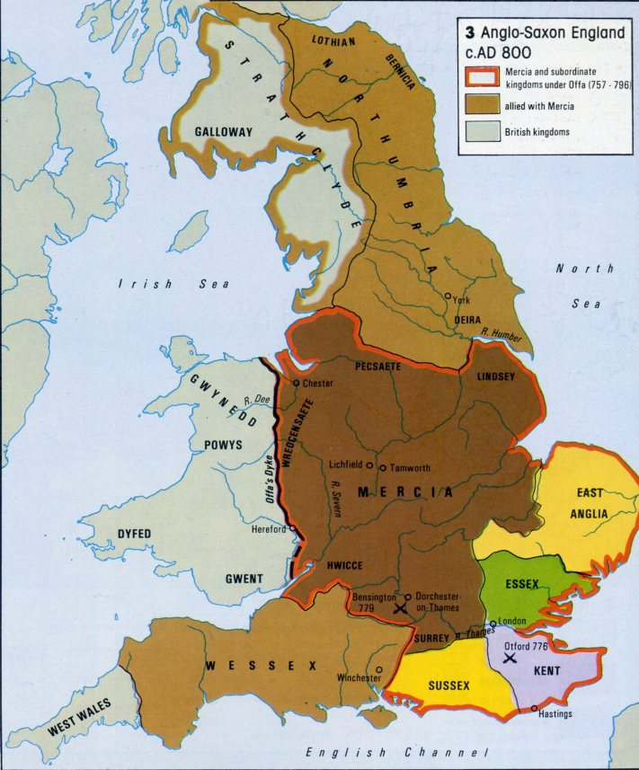[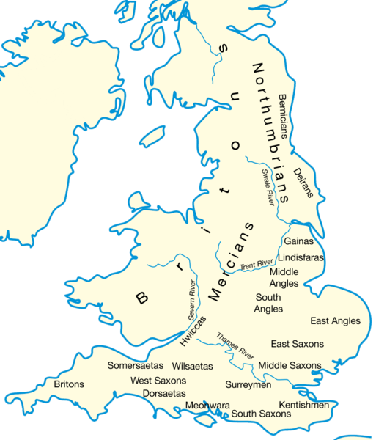](http://upload.wikimedia.org/wikipedia/commons/4/4e/Britain_peoples_circa_600.png)

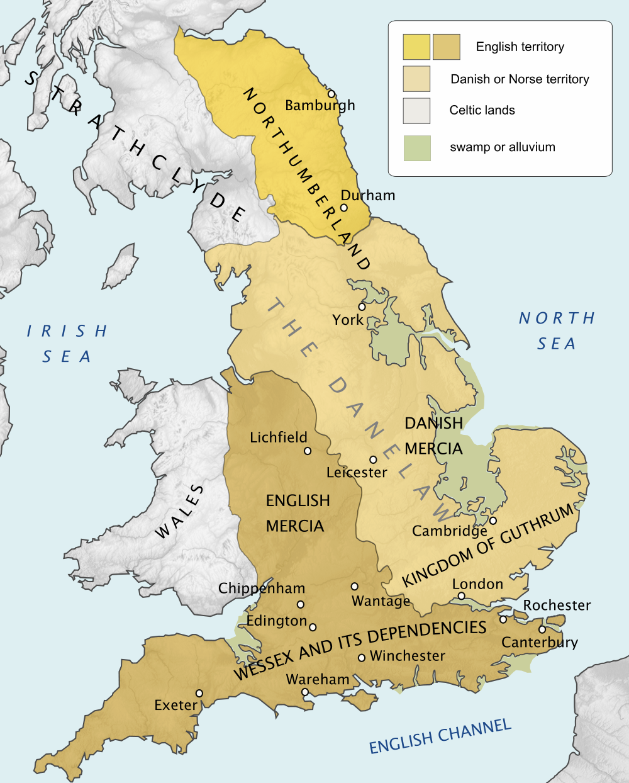

**Map 3: England at the end of the 9th Century**