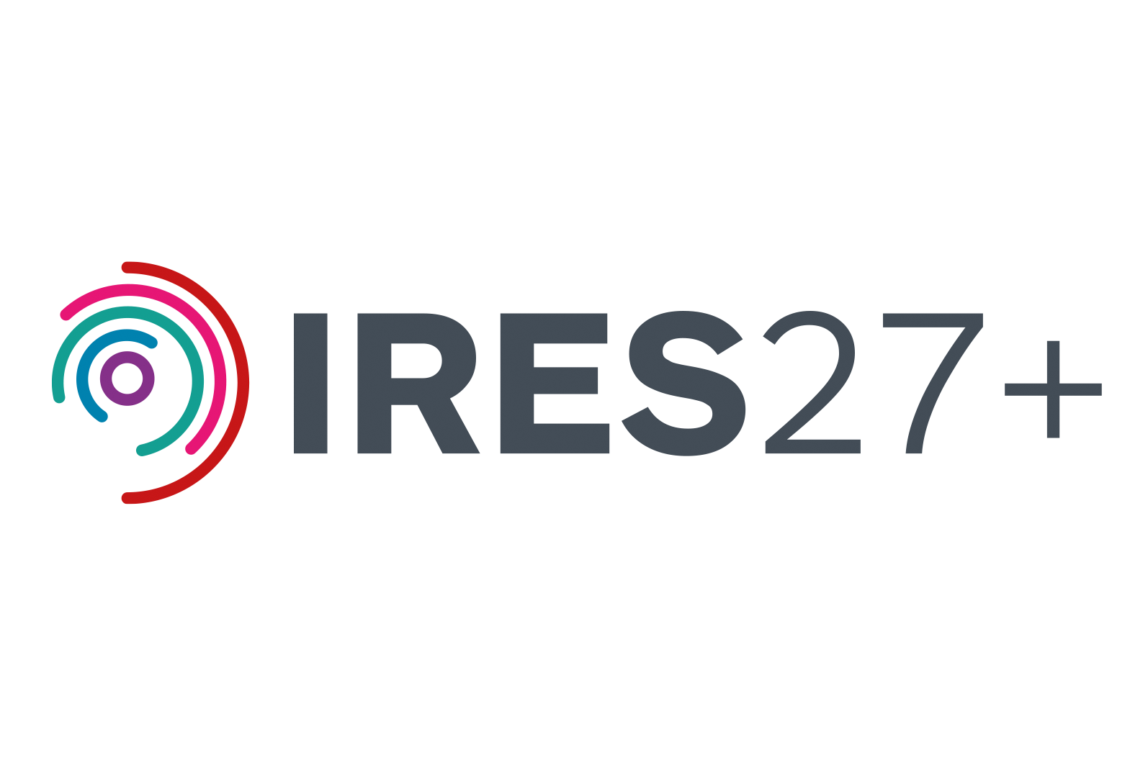
*** October 2026
Màiri McAllan
Cabinet Secretary for Education, Culture and Gaelic
St Andrew’s House, Regent Road, Edinburgh, EH1 3DG

scottish.ministers@gov.scot

CC: Alyn Smith
Minister for Innovation, Technology and Tertiary Education

Dear Cabinet Secretary,
Integrated Regional Employability & Skills (IRES) Programme 2027+
I am writing as [role] at [organisation/project] to set out the case for continued investment in IRES 27+. [In one short sentence, explain your connection to IRES.] IRES has exceeded its targets, attracted significant leveraged funding and built regional skills ecosystem with capability that reaches well beyond its original expectations. It delivers consistent inclusive benefits for people, communities and employers across the region. Without continuity, years of progress, established infrastructure and future investment would be lost.

What IRES has enabled
• [Key achievement or statistic – what has IRES enabled through your work?]
• [Second achievement or statistic – focus on impact for people, employers or communities.]
• [Third achievement or statistic, or one short example of the wider value: partnership, regional reach, employer voice, leverage or social/economic impact.]

What is at risk
Without continuity funding, the region risks losing trusted relationships, infrastructure and cross-boundary capability built over many years. [Add one sentence on what would be lost from your project or organisation’s perspective, and who would be affected.] Once lost, this capability would take years and significant investment to rebuild.

Why continued investment matters
IRES 27+ provides the final intervention, building on poverty and employability investment with the skills and progression routes needed to unlock stuck talent. It will support thousands of people out of poverty into higher-skilled, better-paid jobs, while giving employers access to the workforce needed in growing sectors. [Add one sentence on what IRES 27+ will protect, enable or deliver from your project or organisation’s perspective.]

We strongly urge the Scottish Government to protect its investment in IRES by funding IRES 27+ from April 2027. Without continued skills investment, the wider preventative ecosystem cannot succeed.

Yours sincerely,
[Name]
[Role]
[Organisation / Project]

