The audience for this ‘Social Business Directory’ is specifically large building suppliers and contractors, and the purpose is to draw their attention to your organisation. Try to present your business offer in a way that appeals to this audience.
Please refer to the directory, available for download here, to see how other businesses have presented their offers.
All complete entries, along with a high-resolution logo (attached separately as a JPEG or PNG), should be emailed to the team at info@esescommunities.org for consideration.

- Select your company status
Company Status **
Charitable Organisation - SCIO, Registered Charities, Research Charities
Community Interest Company
Social Enterprise
Workers Cooperative

- Provide the following information which will be displayed as per the example on page 2
Company Name
Link to your website
What geographical areas do you cover?
What does your company do? *
Why should a contractor buy from you versus a competitor? *
A list of previous clients (optional)
Contact email address
*These two sections have a TOTAL word limit of 170.
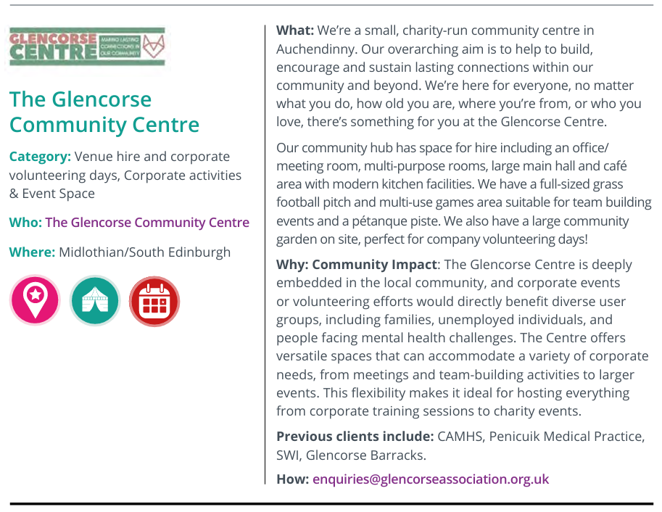

3 - Please put an ‘X’ next to the categories that best describe your organisation:
Category |  | Category |  | Category
Bike Hire/ Active Travel |  | Filmmaking |  | Office Space
Branded Merchandise |  | Food Distribution |  | Printing
Building |  | Furniture Collection and Re-use |  | Public Engagement
Business Support |  | Gifts |  | Publishing
Catering |  | Graphic Design |  | Recycling
Commercial Signage/Engraving |  | Health & Safety |  | Renewables
Copywriting & Copy Editing |  | Human Communication |  | Research
Corporate Activities |  | Leadership |  | Team Building
Display Systems |  | Marketing |  | Tech & IT Peripherals
Document Management |  | Mental Health |  | Therapy/Counselling
Environmental Regeneration |  | Mindfulness |  | Training
Events Space |  | Mobile Catering |  | Venue Hire

All complete entries, along with a high-resolution logo (attached separately as a JPEG or PNG), should be emailed to the team at info@esescommunities.org for consideration.

