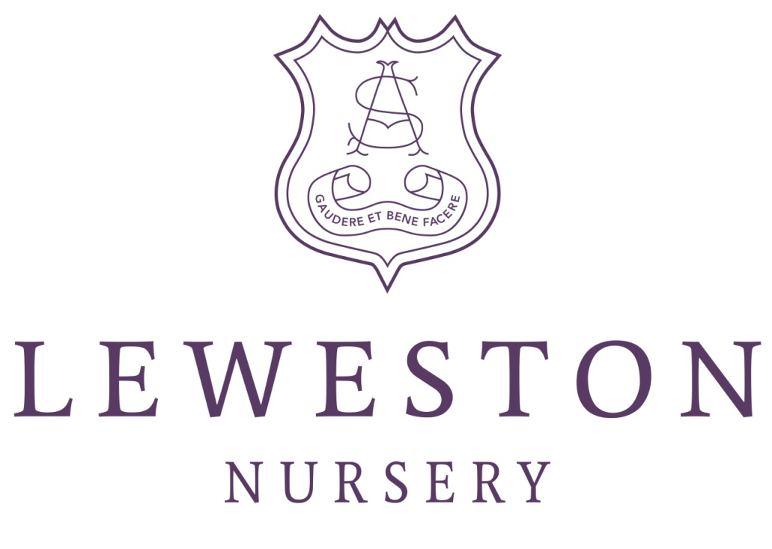

Funding Guide 2018-2019

Funded Childcare for Three and Four Year Olds
How does the funding work?
The government will provide up to 570 hours per annum of standard funding for children aged 3+. They base this on 15 hours per week for the 38 term-time weeks of the year. Additionally, some working families will be eligible for a further 570 hours per annum (15 hours x 38 weeks). This is what is described by the Government as the ‘Free 30 hours of childcare’.
Each County Council is responsible for allocating the funding to the children. Ahead of the start of each term, we make a claim for each child and they inform us how much we can apply. Each term is a different length (in weeks) so the amount allocated reflects that.
The funding year runs from April to April. In 2017-18 the Council decided that it would work out as;
Summer term – 12 weeks funding
Autumn term – 15 weeks funding
Spring term – 11 weeks funding
For children who attend the Nursery for 50 weeks a year, there is a choice – you can either apply a ‘termly stretch’ or a ‘full-year stretch’.
Termly Stretch
The termly stretch shares the amount of funding out evenly over the months that your funding covers, so someone who received 15 hours per week of funding for the Autumn term would have it split out equally over the full period (As their child attends for more than 15 weeks). There were 17 weeks in that term, so they received 13.23 hours funded per week.
In the Spring term there were 13 weeks to stretch the funding over, so the 11 weeks of funding worked out as 12.69 hours funded per week.
In the Summer term, the Council paid funding for just 12 weeks – as the school terms finish in July – but this funding has to be split over the full period of the summer, so that is 20 weeks. This means that over the summer, the funded amount equated to just 9 hours funded per week.
Although the council stipulate how much funding can be used in each term in this way, which makes the funding amount vary, it still totals to the annual allocation of 570 hours.
The number of funded weeks to be used in each term is set by County and this varies slightly, so it is not possible to say very far in advance how much of the funding will be apportioned to each part of the year.
For 30 hours, exactly the same principle applies, but doubled, and for fewer hours, you’ll just have less to stretch. More unique circumstances are modelled later in this guide, which should make it clearer.

Full-Year Stretch
There is an option to spread your funding evenly across the whole year, but this involves ‘locking’ the sessions and funding that you will use for a whole year, split over 2 academic years. This means that you have no scope to increase sessions as your child gets older or to adapt if circumstances change, so I have yet to find a family for whom this would be a good idea.
So, that’s general funding, which applies to every setting in Dorset.
At Leweston
At Leweston in 2017/18 you have been able to use a maximum of 6 hours funding per day (38 weeks per year), or 3 hours per session. This means that, if you have been doing 3 sessions, County will have applied 9 funded hours to you per term-time week, which we would then stretch over the period your child actually attends. If you do at least two and a half days, you’ll have been using the full standard allocation of 15 hours x 38 weeks. If you are eligible for 30 hours funding, you’ll have been continuing to work up in blocks of 3 hours per session, so your child would attend five full days to use their full 30 hours of funding. If they attend for less than that, you’d have received an apportioned amount.
From September, for 2018/19, you’ll be able to use up to 8 hours of funding per day (38 weeks per year). This will make a difference if you don’t currently use all the funding you are eligible for.
So, if your child has been attending for two and a half days a week, instead of only being able to use 15 hours of funding, you could use up to 20 hours (if you are eligible for the 30 hours scheme). If your child does three sessions a week, you’ll be able to use 12 hours funding, whereas currently you can only use 9.
Food funding charges
Dorset County Council apply a set rate to each individual Nursery for a funded hour. An hour at Leweston costs parents £5.10, but County fund that free hour at a base rate of £3.74. Ensuring that a maximum of 6 funded hours could be used each day enabled us to make up some of this loss with the paid hours, but extending to take 30 hours of funding and enabling more funding to be used in a session meant that we could no longer absorb this loss.
The food funding charge is currently applied to all parents who use more than 15 hours funding per week, and from September 2018 it will be applied to all parents who use funding. This is a charge of 95p per funded hour for food and disposables, which makes up the difference between the rate paid to us by County and the actual cost of providing an hour of care.
So, if you use 15 hours of funding you’ll have £76.50 per week deducted (for 38 weeks per year). You’ll then be charged £14.25 for food and disposables, so you’ll still make a saving of £62.25 per funded week or £2365.50 per annum. If you use 30 hours of funding, you’ll have £153 per week deducted and will be charged £28.50 for food and disposables, making a saving of £124.50 per funded week or £4731.00 per annum.
You’ll find more of the varied individual circumstance examples later in this document.

Applying for funding
A child born in the period | Will become eligible for funding
1st April to 31st August | 1st September following the child’s 3rd birthday (Autumn school term)
1st September to 31st December | 1st January following the child’s 3rd birthday (Spring school term)
1st January to 31st March | 1st April following the child’s 3rd birthday (Summer school term)

The 15 hours (for 30 weeks)/570 hours of Early Years Funding is universal for three and four year olds, so there is no need to make a formal application online for this. We apply on your behalf via Dorset County Council. You will receive a form from us in the term before your child turns three, asking you to confirm the sessions in which you’d like to make use of funding, how much you’re planning to use and whether you’ll be using any funding elsewhere (At another Nursery/childminder/holiday club).
It is really important to fill this in carefully so that you don’t over or under apply. Over applications can result in real challenges, as the funding from Dorset County Council will be stopped until your account is level again, so we won’t be able to make any deductions to your bills.
The form is then handed back to us and the data is sent to County who will then confirm what you are allowed and tell us how much will be received. We then deduct the correct number of allocated hours from your bills, and County transfer their contribution towards that to us.
Applying for 30 hours funding
The 30 hours free childcare offer is for working families in England with 3 and 4 year old children. Children are eligible from the term following their 3rd birthday until they reach compulsory school age, just as per the chart for the 15 hours. 30 hours works in the same way – you have funding for up to 30 hours per week for 38 weeks of the year.
In order to be eligible, parents must be working and each earning at least the National Minimum or National Living wage for 16 hours a week (£125.28 if you're over 25). You won't be able to claim if either you or your partner has a taxable income over £100,000.
Applying for the 30 hours funding is a little more complicated, and it is advised that you start the application process around 3 months before your child turns 3.
To apply and claim the funding:
- complete the online form and set up a childcare service account here;
https://www.dorsetforyou.gov.uk/children-families/childcare/childcare-funding/30-hours-free-childcare/how-and-when-to-apply-for-30-hours-free-childcare.aspx
- if you're eligible you will get an eligibility code which you must give to us
- you must reconfirm your eligibility every 3 months after applying (even if you haven't started claiming your extra hours)
You can only claim at the start of each new term, if your child is eligible to claim. If you fall eligible during the term you will need to wait until the start of the next to get your extra hours.
There are set dates by which you must have completed your application. If you miss these, you will miss out on the whole term of funding, so it is important to remember those dates. The same applies if you forget to keep reconfirming, but it is worth the hassle for the savings you make.

Can I use funding on additional ad-hoc sessions?
No. Unfortunately the funding received is set in advance, so no changes can be made to a term once it has begun, and that includes ad-hoc sessions and additionals.
When does the funding stop?
Children are eligible for funding up to and including the term in which they turn five. If your child stays at Leweston in Reception, the funding can be deducted from the fees as detailed below. If your child transfers to a state primary school, the funding will be automatically applied to them.
 | Autumn Term | Spring Term | Summer Term | Annual fee due  for Reception year
5th Birthday between 1st September and 31st December | £1975 termly fee  - £1885.50 funding  Total to pay = £89.50 | £1975 termly fee  No funding to deduct | £1975 termly fee  No funding to deduct | £4039.50
5th Birthday between 1st January and 31st March | £1975 termly fee  - £1885.50 funding  Total to pay = £89.50 | £1975 termly fee  - £1382.70 funding  Total to pay = £592.30 | £1975 termly fee  No funding to deduct | £2656.80
5th Birthday between 1st April and 30th August | £1975 termly fee  - £1885.50 funding  Total to pay = £89.50 | £1975 termly fee  - £1382.70 funding  Total to pay = £592.30 | £1975 termly fee  - £1508.40 funding  Total to pay = £466.60 | £1148.40
* This is based on the assumption that DCC will fund the blocks as they did for 2017/18, so with 15 weeks funded in Autumn, 11 weeks funded in Spring and 12 weeks funded in Summer.
Who can get funding for two-year olds?
Families with a household income below £16,190 can apply for 570 hours of annual funding for two year olds, provided that a certain set of criteria are met. You have to use these hours in a ‘Good’ or ‘Outstanding’ setting, so we are able to receive this funding.
You can find more information about your eligibility and how to claim;
https://www.dorsetforyou.gov.uk/children-families/childcare/childcare-funding/free-early-education-and-childcare-for-2-year-olds.aspx
Examples of funding scenarios
Child A
Child A attends Nursery for 6 sessions a week, or 3 full days. They attend term-time only, but stay until 6pm daily.
 | Weekly bill with no funding (38 weeks) | Annual bill with no funding | Weekly food funding charge | Weekly bill with funding (38 weeks) | Annual deduction | Annual bill remaining to pay
June 2018 | £153.00 | £5814.00 | £17.10 | £61.20 | £3488.40 | £2325.60
September 2018  (Up to 8 hours funding per day, food funding charge applied) | £153.00 | £5814.00 | £22.80 | £53.40 | £4651.20 | £1162.80

Child B
Child B attends Nursery for 6 sessions a week, or 3 full days. They attend full-time, so 50 weeks per year.
 | Weekly bill with no funding (50 weeks) | Annual bill with no funding | Food funding charge | Weekly bill with funding (38 weeks funding split over 50) | Annual deduction (Funding minus food charge) | Annual bill remaining to pay
June 2018 | £153.00 | £7650 | £12.99 per week | £96.22 | £2838.90 | £4811.40
September 2018  (Up to 8 hours funding per day, food funding charge applied) | £153.00 | £7650 | £17.32 per week | £75.69 | £3784.80 | £3865.20

Before Child B received funding, they paid £153.00 per week. When they could only use 18 hours of funding each week (2017-18) they paid £83.24 per week. From September they will be able to use 24 hours of funding, so despite the food funding charge coming into force, they will only pay £75.69 per week for the same amount of time in Nursery.
County are likely to allocate the amount of funding to each term in a similar way to that they have this year, so 12 weeks for Summer, 15 for Autumn and 11 for Spring.

Child C
Child C attends Nursery for 10 sessions a week, or 5 full days. They attend full-time, so 50 weeks per year. Their food funding charge came into force in April, when they started to claim the 30 hours funding. Nothing will change for them in September.
 | Weekly bill with no funding (50 weeks) | Annual bill without funding | Food funding charge | Weekly bill with funding (38 weeks funding split over 50) | Annual deduction | Annual bill remaining to pay
June 2018 | £255.00 | £12750.00 | £21.66 per week | £138.72 | £4731.00 | £8019.00
September 2018  (Up to 8 hours funding per day, food funding charge applied) | £255.00 | £12750.00 | £21.66 per week | £138.72 | £4731.00 | £8019.00

Child D
This child starts the Nursery in September 2018, doing 4 sessions a week, on a full year contract. At Christmas they increase their sessions to 6 a week, and for the Summer term they increase to 8 sessions a week.
 | Weekly bill with no funding | Funded hours used | Food funding charge | Weekly bill with funding (Funded weeks split over weeks attended with food charge) | Termly bill with funding and food charge
Autumn Term (15 weeks funded, 17 weeks attended) | £102.00 | 16 | £15.20 per funded week (38 weeks) | £43.41 | £738.00
Spring Term (11 weeks funded, 13 weeks attended) | £153.00 | 24 | £22.80 per funded week (38 weeks) | £68.72 | £893.40
Summer Term (12 weeks funded, 20 weeks attended) | £204.00 | 30 | £28.50 per funded week (38 weeks) | £129.30 | £2586.00

I really hope that this guide helps you to understand the way in which the funding is calculated, but as you can see, it is a very complicated system. The way that the funding works and is applied really is based upon your individual circumstances, and the different ways that County apportion the funding each year. We are always very happy to demonstrate how the funding might work in your personal circumstances, based on the estimated allocations for the coming terms.
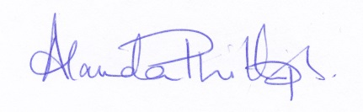
Alanda Phillips
Head of Prep and Early Years
Nursery Manager
June 2018

N.B. Leweston Nursery does not accept any responsibility if the above example figures do not reflect those that appear in your bill due to the nature of the way in which County control the apportionment of the funding. They are examples only and are to be treated as such.

